Ebay profit project
http://www.casinkadmin.com/liang/ebayproject/totalactivelist.php

1.1 Add Active List
It will add the items into db, allows add duplicated Custom label. This table in db is “ebay_activelist”.

1.2 Show Active List
It will display all the items in table “ebay_activelist”, but if one item have more than one records, it will show the most recent one.

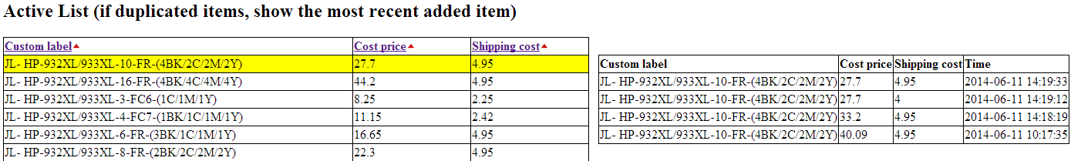

1.3 Show Ebay Active List
Show all the items from ebay’s active list, the table in db is “ebay_trading”, the list is generate daily, I fetch data from our ebay’s account.
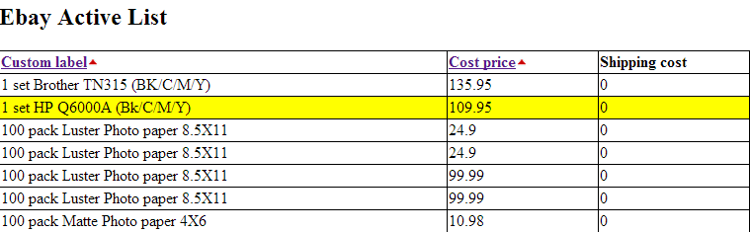

1.4 Merge Active List
Merge the ebay’s active list (Price) and our input active list (Cost Price) together, calculate the profit. If the profit is less than $5, i will mark as red.

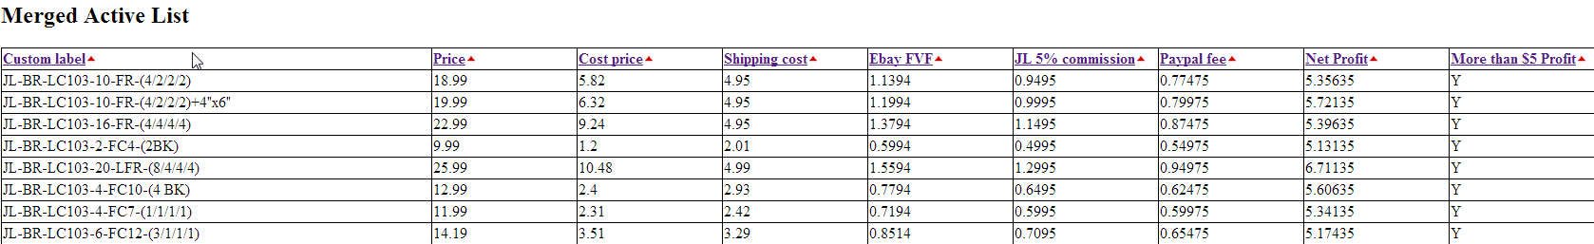
Custom Label ( inner join of active list and ebay active list)
Price (from ebay active list)
Cost price (from active list input manually)
Shipping cost (from active list input manually)
Ebay FVF (Price*0.06)
JL 5% commission (Price*0.05)
Paypal fee (Price*0.025+0.3)
Net Profit (Price-Cost price -Shipping cost-Ebay FVF-JL 5% commission-Paypal fee)

1.5 Difference Active List
Display all the item are in ebay but not in active list (not input manually yet)
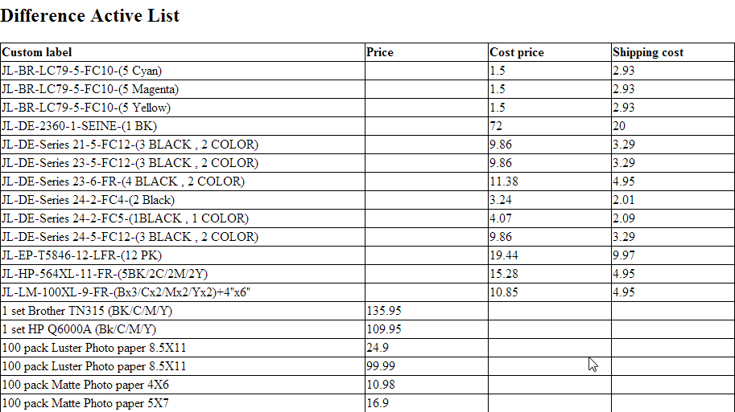

1.6 Fetch Active List from ebay
www.casinkadmin.com/liang/ebayproject/insertDB.php

1.7 Email reminder
www.casinkadmin.com/liang/ebayproject/email.php

